**Test Document for Modification in Payment detail IR wise - Add non finalised option**

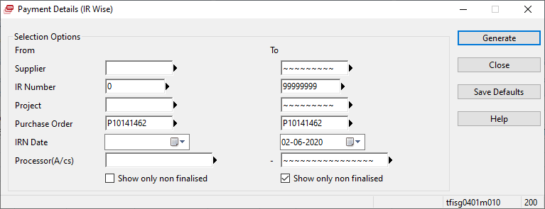

Testing without Show only non finalised, then

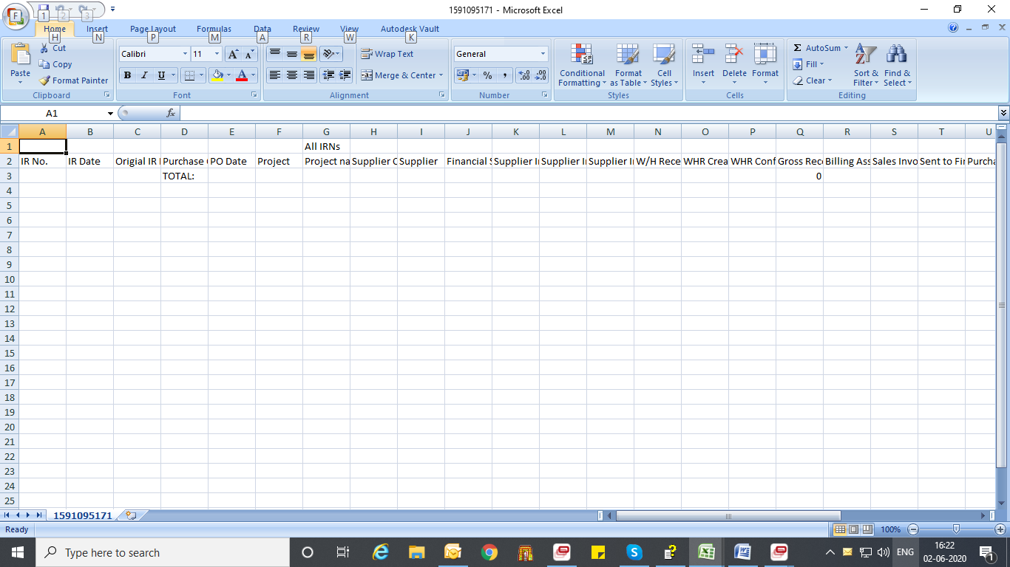

No data found

After testing in all data

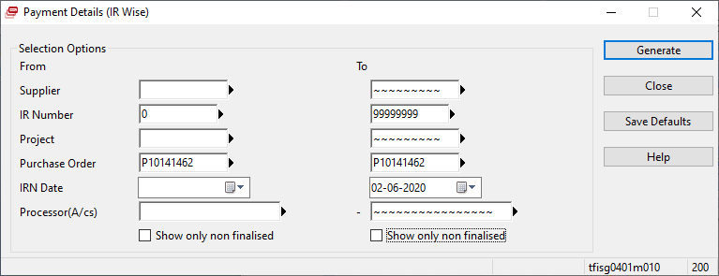

Results

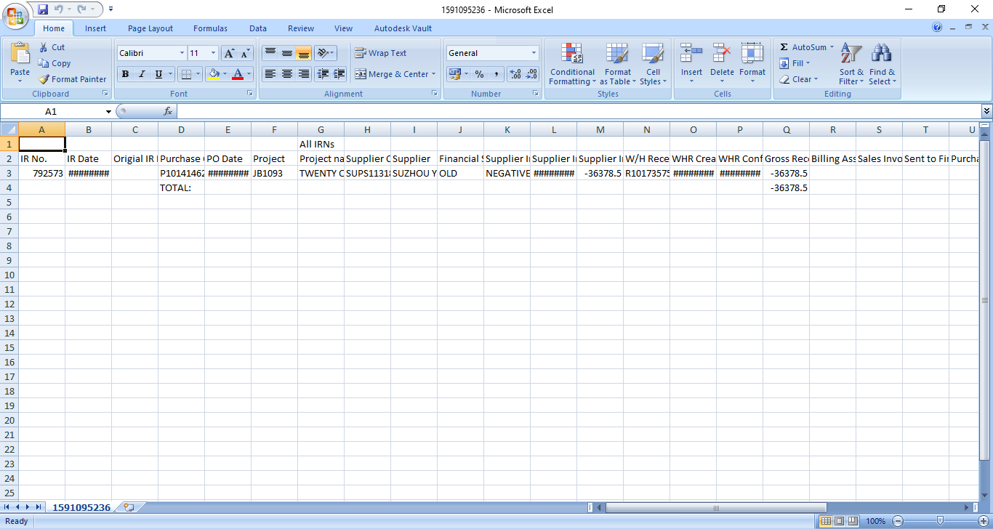

IR no 792573 contain no invoice no so IR comes there